Exp11 and Exp12 CPT –

Routing using OSPF

Muthu Venkatesh M

24BCE1389

Github link: https://github.com/muthuvenkatesh-24/Computer_networks_lab

Ospf output:

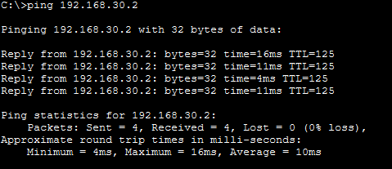

1. Open Cisco Packet Tracer and create a new workspace.

2. Add three routers (R0, R1, R2) and three PCs (PC0, PC1, PC2) to the workspace.

3. Connect each PC to its respective router using copper straight-through cables.

4. Connect routers using serial DCE cables (R0–R1 and R1–R2).

5. If serial interfaces are not available, add HWIC-2T modules from the Physical tab of the router.

6. Assign IP addresses to all router interfaces (GigabitEthernet and Serial) and configure IP addresses for all PCs along with the correct default gateway.

7. Enable all interfaces using the command:

no shutdown

8. Enter global configuration mode and configure OSPF using:

router ospf 1

9. Advertise all directly connected networks using:

network <network-address> <wildcard-mask> area 0

10. Ensure that all routers are configured in the same OSPF area (Area 0) to establish neighbor relationships.

11. Verify OSPF operation using:

show ip ospf neighbor

show ip route

12. Test end-to-end connectivity between PCs using the ping command.

13. Save the configuration as ospf.pkt.

RIP output:

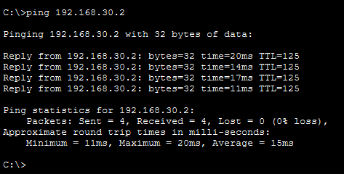

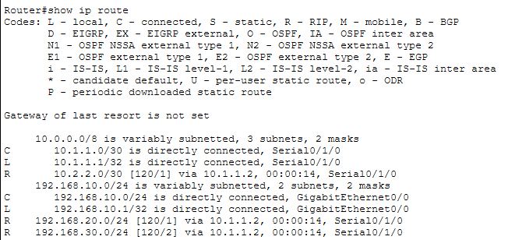

1. Open the OSPF configuration file and save it as a new file named rip.pkt.

2. Remove the existing OSPF configuration using:

no router ospf 1

3. Enter global configuration mode and enable RIP using:

router rip

4. Set RIP version 2 using:

version 2

5. Advertise the connected networks using:

network <network-address>

6. Disable automatic summarization using:

no auto-summary

7. Verify RIP configuration using:

show ip route

8. Ensure that routes are learned and marked with “R” in the routing table.

9. Test connectivity between PCs using the ping command.

10. Save the configuration as rip.pkt.

EIGRP output:

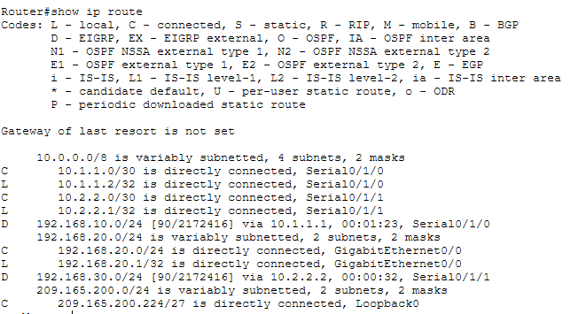

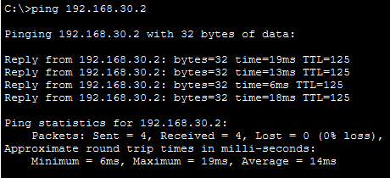
1. Open the OSPF configuration file and save it as a new file named eigrp.pkt.
2. Remove the existing OSPF configuration using:
no router ospf 1
3. Enter global configuration mode and configure EIGRP using:
router eigrp 100
4. Advertise the connected networks using:
network <network-address>
5. Disable automatic summarization using:
no auto-summary
6. Verify EIGRP configuration using:
show ip route
7. Ensure that routes are learned and marked with “D” in the routing table.
8. Test connectivity between PCs using the ping command.
9. Save the configuration as eigrp.pkt.

